Pinewood Homes Association Board Meeting

December 13 , 2025 (Final Board Meeting for 2025)

In attendance: Rob Foley, Sandy Schweikert, Bonnie Gwin, Tania Mukherjee, Ajit Kanerkar and Carol Adams and homeowners (sign in list attached) and MAK (Paul Klemanski)

Meeting Minutes:

- Rob Foley called the meeting to order
- Purple house issue (lot #42) brought up for further discussion as the homeowner and their contracted painter had spoken with Rob Foley more than once declaring that they had been in contact with Tania earlier in the year prior to painting to review color and that she had approved it. Tania denied having any correspondence in her email, texts, phone message files and so Board voted and approved to move forward with the current color as is.
- Lot #32 - vote approved to accept new roof material and color submitted to Tania
- Lot #32- vote approved to accept new roof material and color submitted to Tania
- Lot #R25 - vote approved to accept new paint color submitted to Tania
- Rob introduced and reviewed documents re: conflict of interest for Board members to sign in the future avoiding any conflict of interest of any kind and Board approved the documents.
- Paul (MAK) presented his perspective on how important the conflict of interest documents were as the Board is a business entity and this is a protection against wrongdoing as it relates to conflict of interest.
- Rob presented the idea of implementing a governance committee to oversee the Board overall. Voted and passed.
- Ajit spoke to the $500 annual dues voted on in an earlier meeting for 2026 and also mentioned the $64,900 annual operating budget that we had to work with.
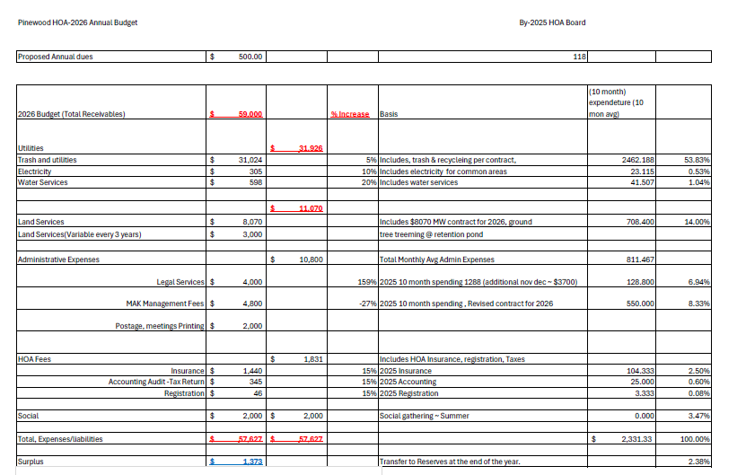 | 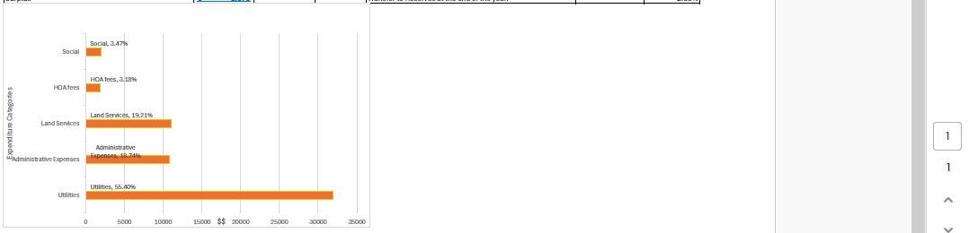

New election ballot counting proceeded to take place and process led by Kathryn, Tracy and Angel (homeowners). Envelopes were opened, sorted and ballots were read for hand counting. One envelope was not postmarked by the deadline of Dec 8th and therefore was not opened and not counted.
- Results of election are Ajit Kanerkar, Salil Kulkarni and Tania Mukerjhee winning the most votes and therefore will be the new 2026 Board members.
- Meeting adjourned

Attached you will find the sign up list of homeowners attending the meeting and the manual ballot count representing the new election results:

