The Pinewood Press
Fall www.PinewoodHOAOpKS.com Nov 2025
Welcome to your Pinewood Homes Newsletter. A short, monthly publication to keep you informed.


2026 HOA BOARD ELECTION BALLOT

Ballots will be sent out this week. The Ballot return envelope must be mailed back to: Pinewood HOA, 7111 W. 151st St. PO Box 43, Overland Park, KS, 66223. Must be postmarked
by Dec 8, 2025. The Ballots will be opened and counted at the next Annual Meeting.

The Annual Meeting will be held at Pleasant Ridge Middle School, located at 9000 W. 165th St, Stillwell, KS, 66085 on Saturday, Dec 13, 2025 from 9:00 to 11:00 approximately.

Pinewood homeowners are invited to attend and observe. The ballots will be counted by the current HOA Board. Results will be posted on the website.

Why Your Vote is SO Important

Did you know that the future of 118 homes in Pinewood in 2026 will be decided by 2 of 3 people elected to the HOA Board. Per the current By-Laws, only three members can serve as voting members of the Board, and 2 of 3 is the majority. This means other people can be added to the committees, but CAN NOT VOTE.
THIS IS WHY YOUR VOTE IS SO IMPORTANT! Please VOTE!

Cold weather is right around the corner. If you have not done this already, it’s a good idea to disconnect all garden hoses prior to a hard freeze, bring in your hoses and get your sprinklers serviced for winter.

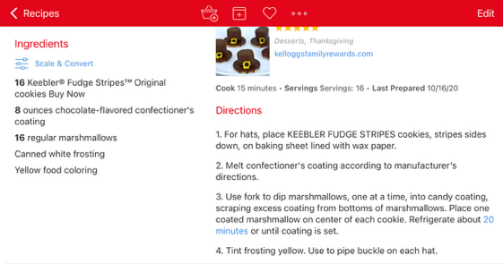 | Holiday Eating: Enjoy the Season Without the Stress  Don’t Skip Meals  Prioritize Your Favorite Foods  3. Choose Your Beverages Wisely  4. Add Color to Your Plate  5. Eat Mindfully  6. Take a 5-10 minute walk after a meal or before leaving for an event

Our condolences to Jim and Cheri Kenny on the passing of Jim’s sister.

Have a Safe and Happy Thanksgiving with your Family and Friends

